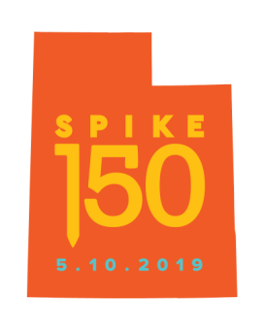**FACT SHEET**

**Golden Spike Foundation**

60 S. 600 E., Suite 150

Salt Lake City, UT 84102

Media Contact: Cindy Gubler 801-971-5639, cindy@wfandco.com

Facts About “Distant Thunder” Bronze Sculpture

*Majestic, 3,000-Pound Bison Sculpture to be Formally Unveiled During 150th Anniversary Celebration of the Transcontinental Railroad; Will be Gifted to Golden Spike National Historical Park*

**THE SCULPTURE: “DISTANT THUNDER”**

* Life-size bison sculpture made from bronze.
* Weighs about 3,000 pounds.
* Took sculptor Michael Coleman nearly one year to create.
* 12-foot-long sculpture started as 12-inch clay “mockette” used to create a 3-D foam form, which was covered with 600 pounds of clay and then cast using “lost wax” method by expert metal finisher Ed Conder at Quality Metal Works in Lehi, Utah.
* Called “Distant Thunder” in recognition of the ground-shaking sounds made by both a herd of galloping bison and the “Iron Horse” locomotives that rumbled across the high desert terrain of the Utah Territory.

**THE SUBJECT: AMERICAN BISON**

* While the words “bison” and “buffalo” are used interchangeably, the proper term is “American bison” or simply “bison”.
* The scientific name of the species is *Bison bison.*
* Designated America’s national mammal on May 9, 2016.
* North America’s largest mammals; a bison calf weighs 30-70 pounds at birth.
* Millions of bison roamed North America in prehistoric times – ranging from Alaska to Mexico and from the Great Basin to the Appalachian Mountains.
* Considered a sacred animal and religious symbol among Native American tribes, especially the Plains Indians.
* Were hunted to near-extinction by late 1800s; a handful of private individuals saved the species.

**THE ARTIST: MICHAEL COLEMAN**

* Provo, Utah native Michael Coleman is internationally known for his award-winning sculptures and paintings of the landscape and wildlife of the American West.
* Coleman has a lifelong fascination with bison, which appear frequently in his art.
* Says Coleman: “When I was growing up there was a private herd of bison near Utah Lake. I used to ride my bike a really long way just to sit and watch them, they were enormous, and I’d make sketches with a pencil and any paper I had with me.”
* “The first painting I ever sold was of a herd of bison.”

**THE DONORS: NAOMA TATE & FAMILY OF HAL TATE**

* “Distant Thunder” was commissioned by Naoma Tate and the Family of Hal Tate.
* Will donate sculpture for permanent display at the Golden Spike National Historical Park.
* Says Naoma Tate: “When we first spoke with Michael about this project, we expected excellence, but ‘Distant Thunder’ is above and beyond that. I was truly captivated by both its strength and vulnerability when I saw it for the first time. This powerful work embodies the raw beauty, untamed spirit and complex history of the American West.”

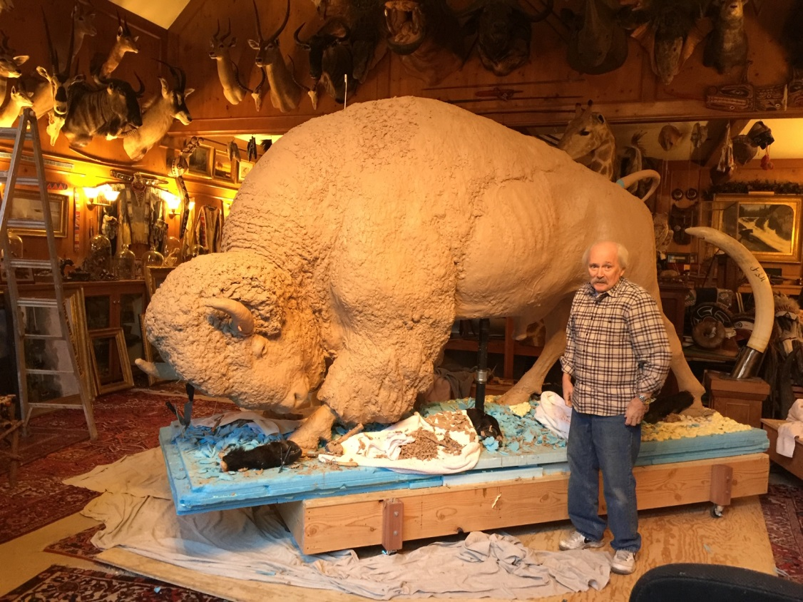

(Left and below)

Internationally renowned Utah artist Michael Coleman works on 3,000-pound, life-size bison sculpture, “Distant Thunder”, at his studio.



  